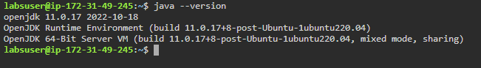

Verifying Java install.

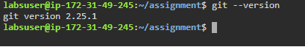

Verifying git install

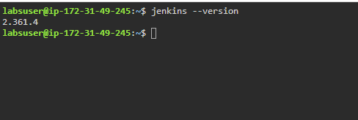

Verified that Jenkins has been installed in this instance. I will be using the practice lab client for this assignment.

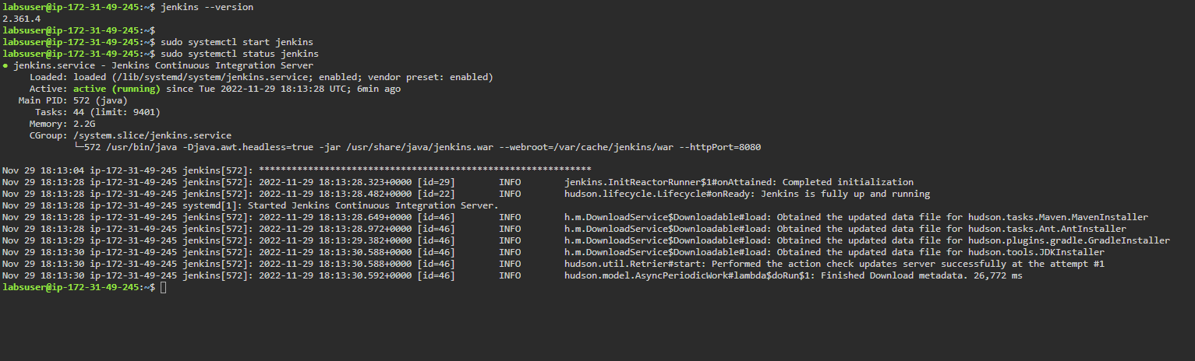

Making sure Jenkins is running on the master node.

As you can see, the status command returned the service as actively running.

Now, I will be swapping over to the GUI of the Ubuntu to setup the Jenkins.

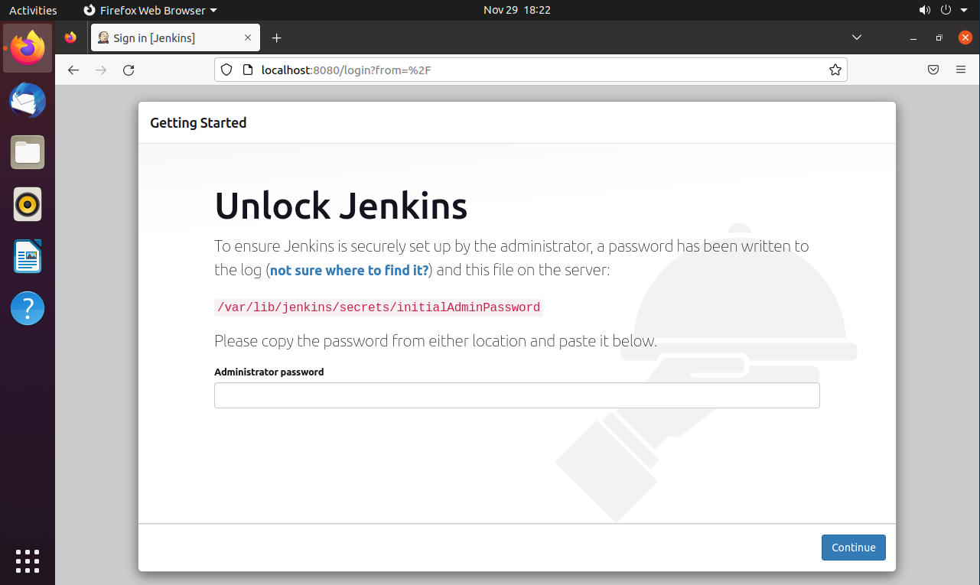

Jenkins landing page via localhost:8080.

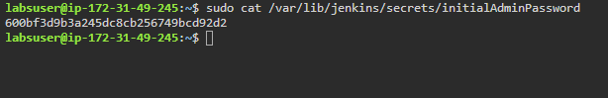

To find the password, I used the cat command along with sudo permission to access the password.

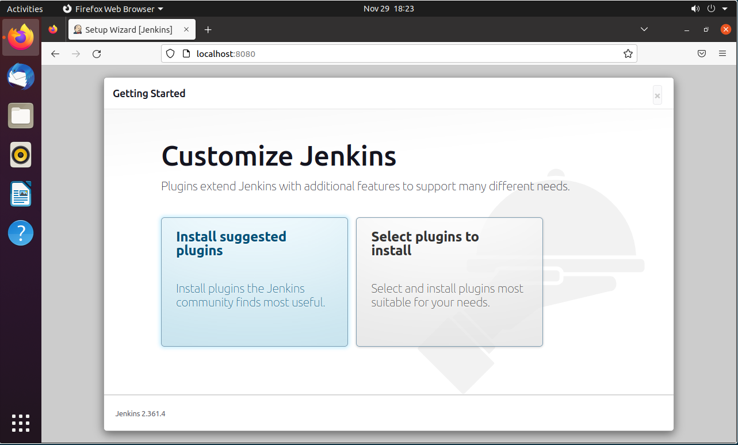

Will be installing suggested plugins.

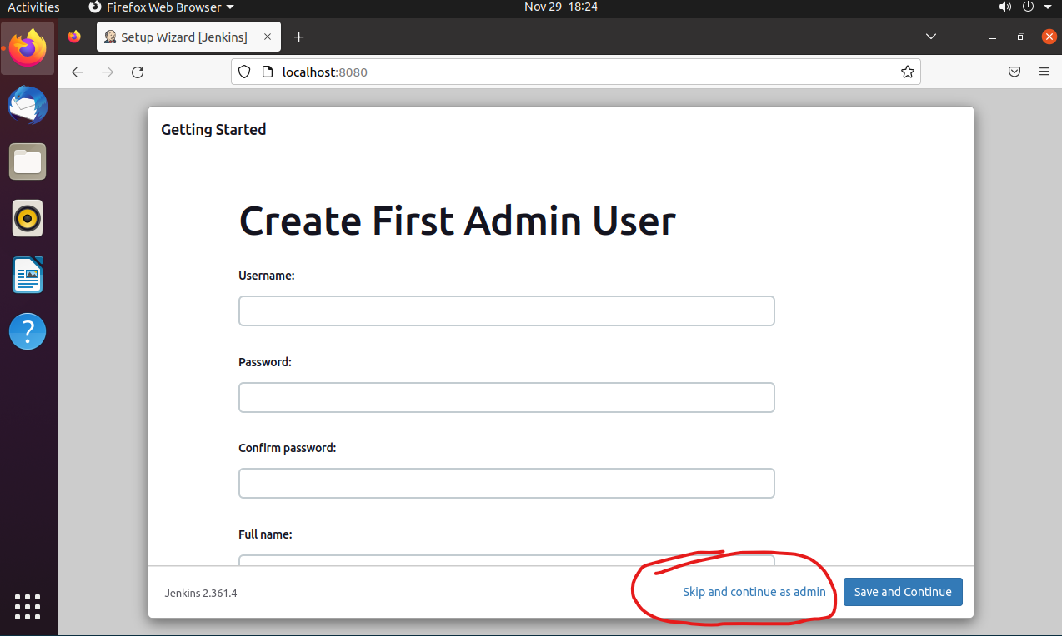

I will be continuing as admin for this project’s simplicity sake.

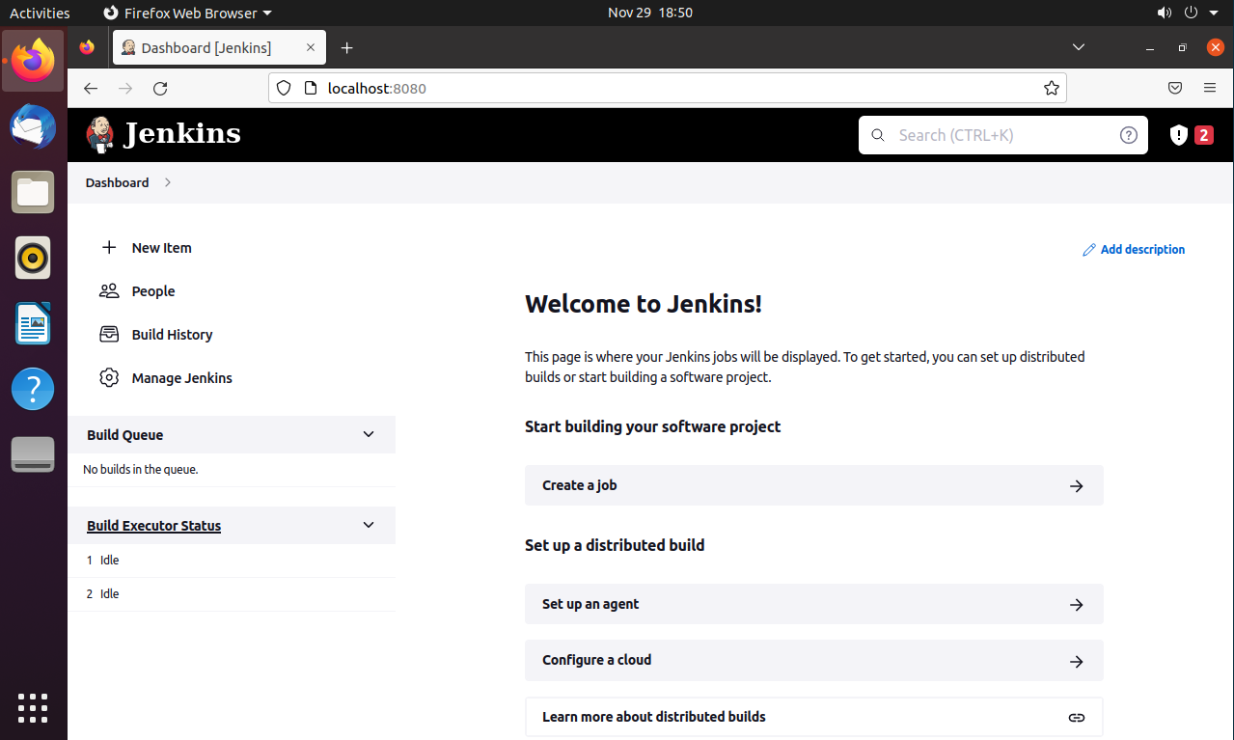

Landing page. I had to disable security since it crashed on me and was asking for admin password, which I did not have.

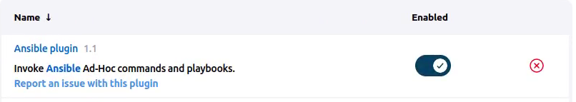

Installed Ansible plugin.

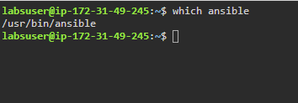

Locating ansible for the executable path.

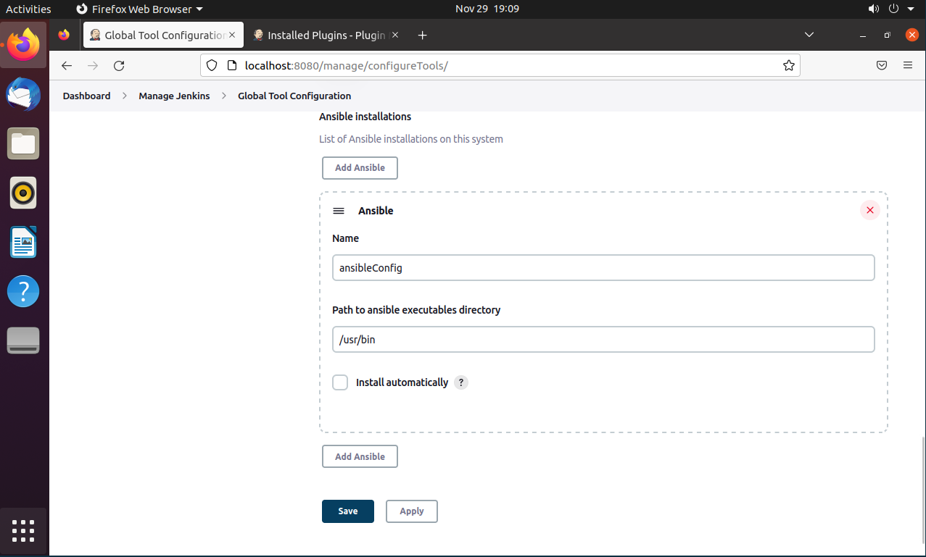

Adding path to ansible

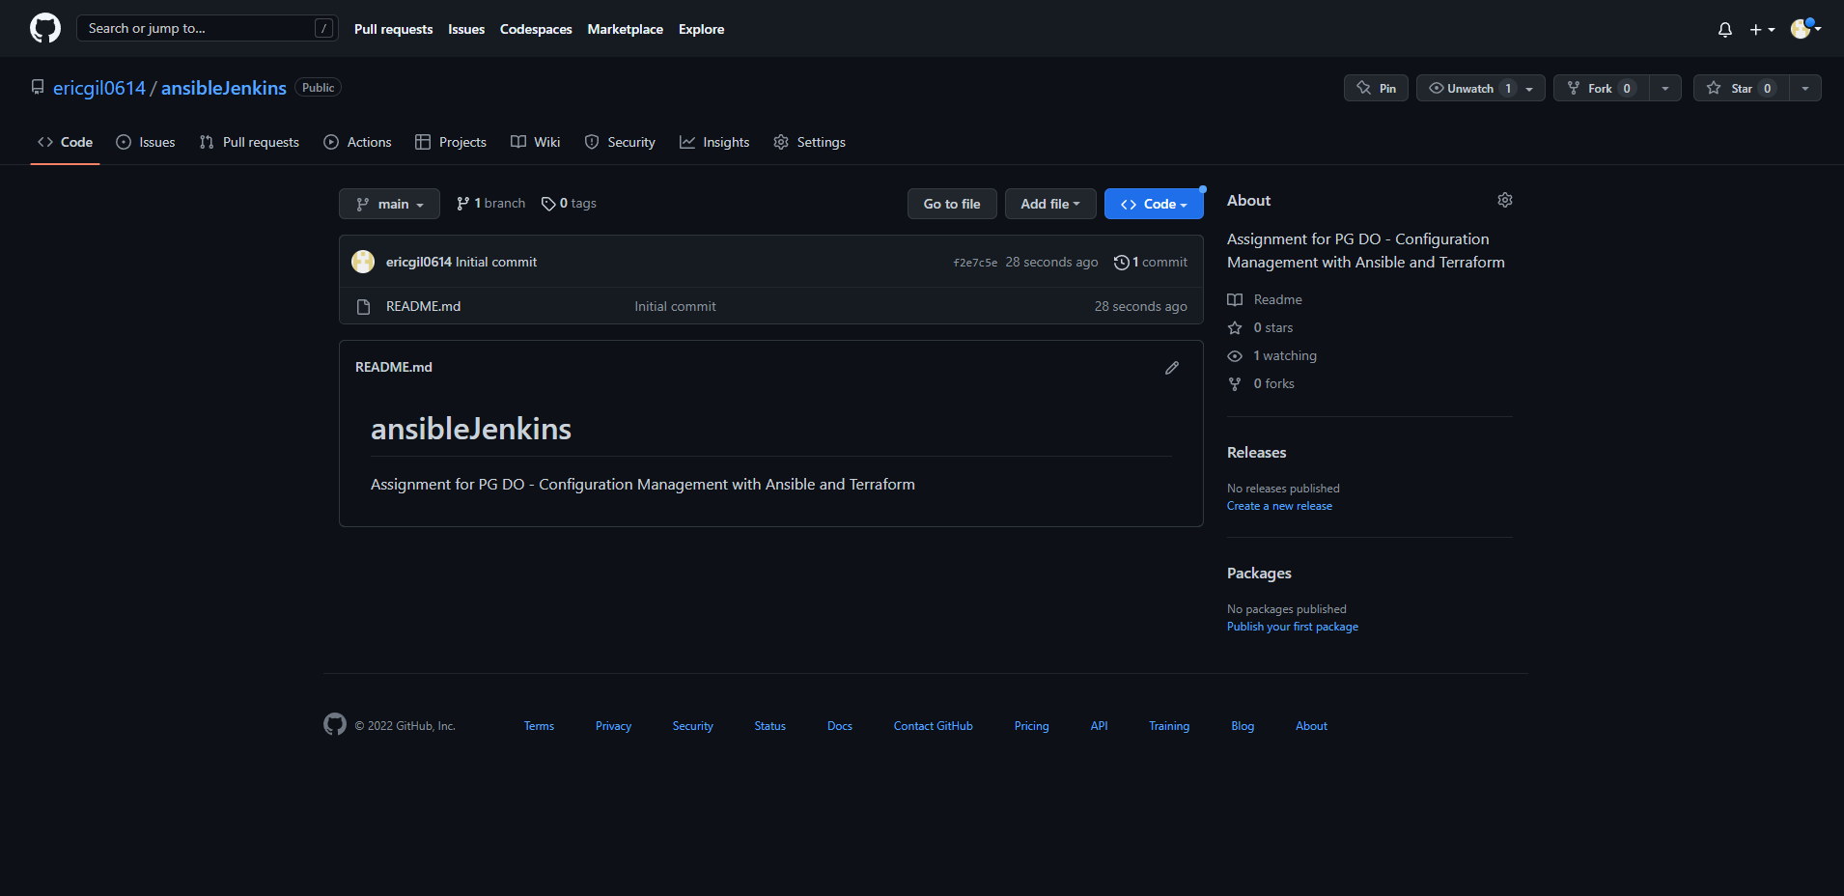

Created git repo for ansible codes to push to.





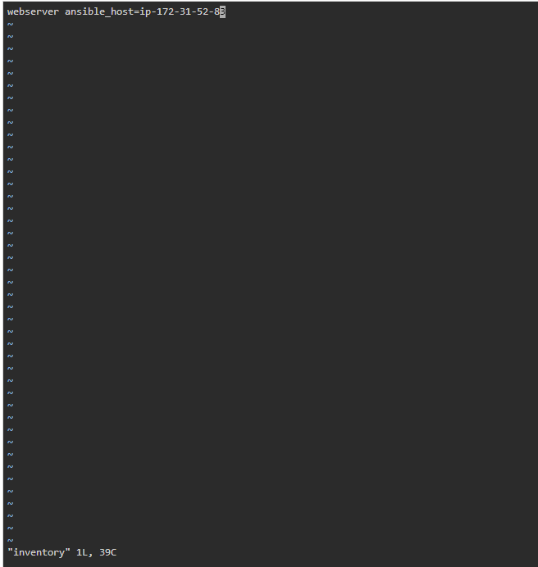

Will be using worker1 node for inventory.

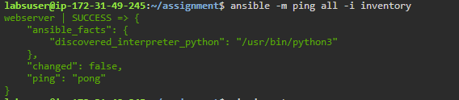

Is reachable from the mater node.

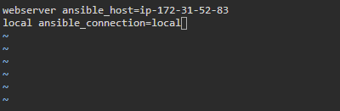

Adding the master machine as local ansible machine.

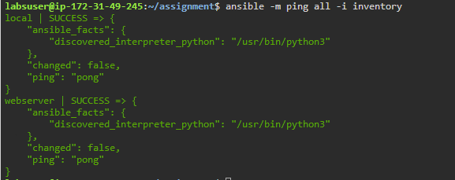

Able to ping both nodes now.

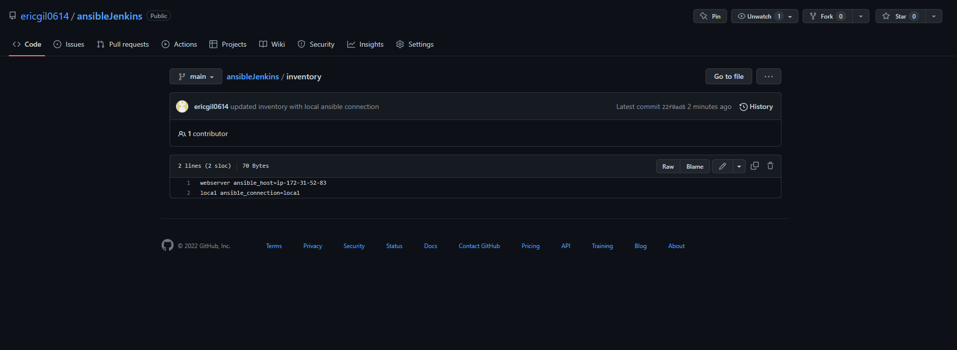

After testing the inventory connections, I upload them to github.

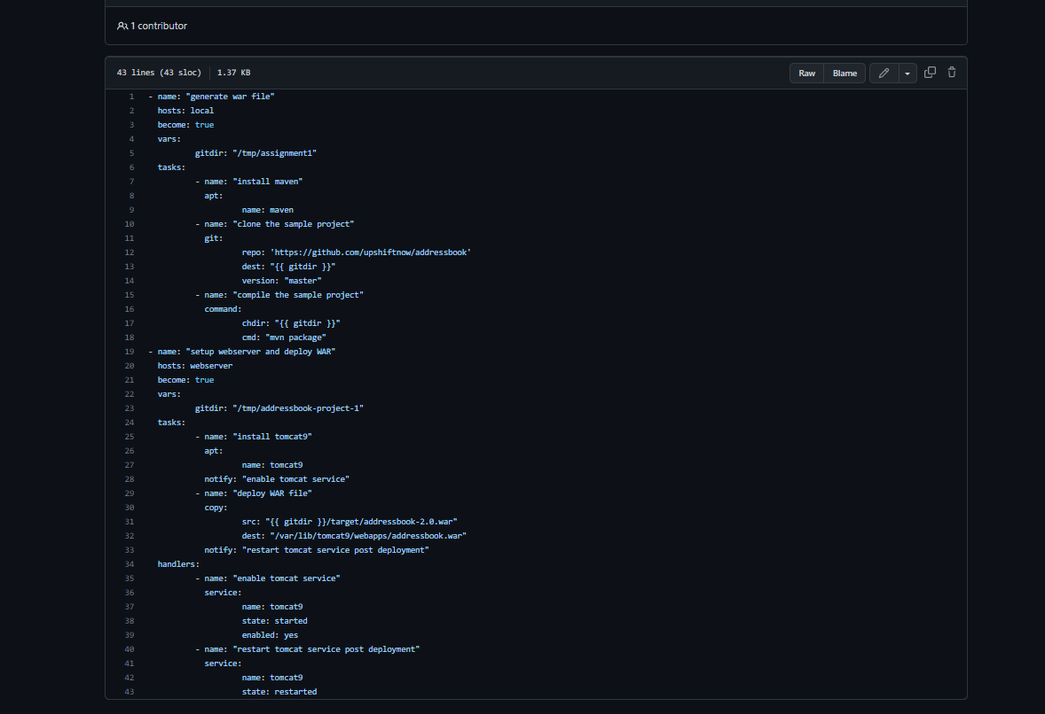

Writing main playbook to connect to another git repo, clone it, and build it.

Also makines sure we installed tomcat and make sure it is started.

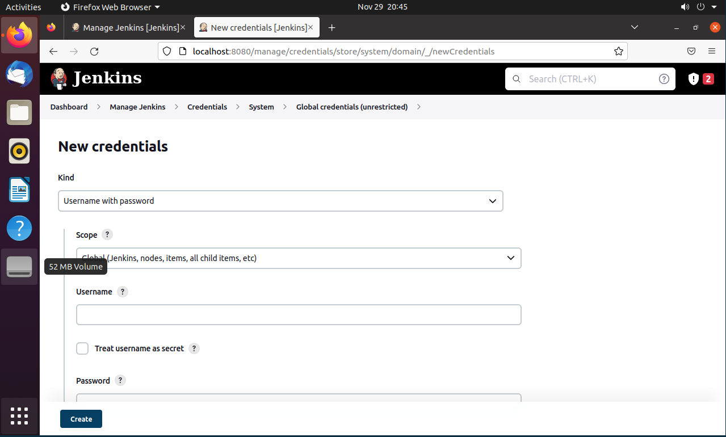

Adding ssh credentials

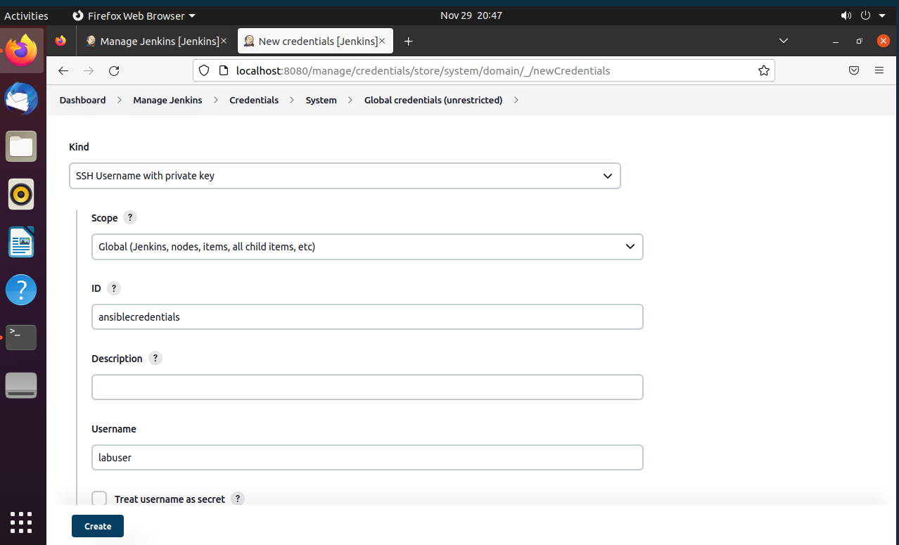

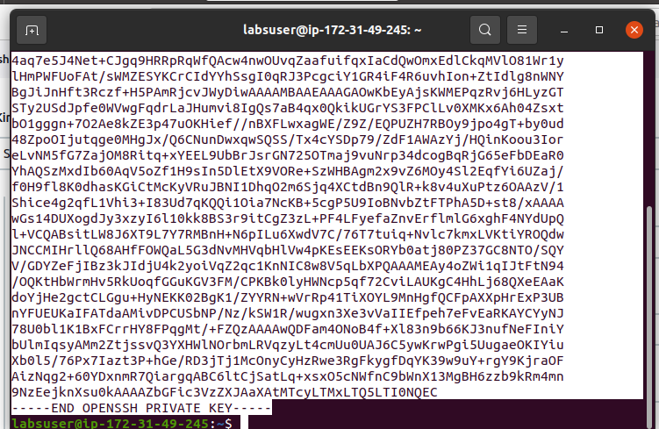

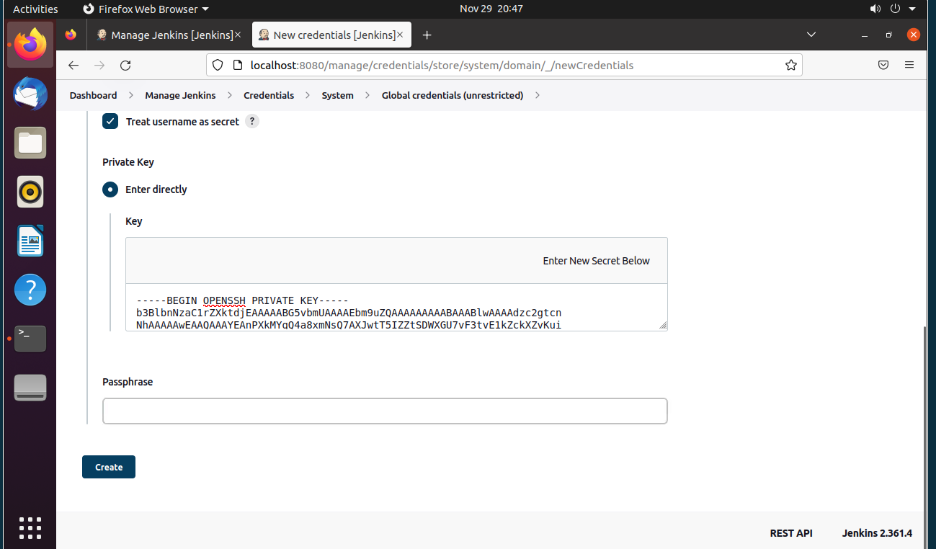

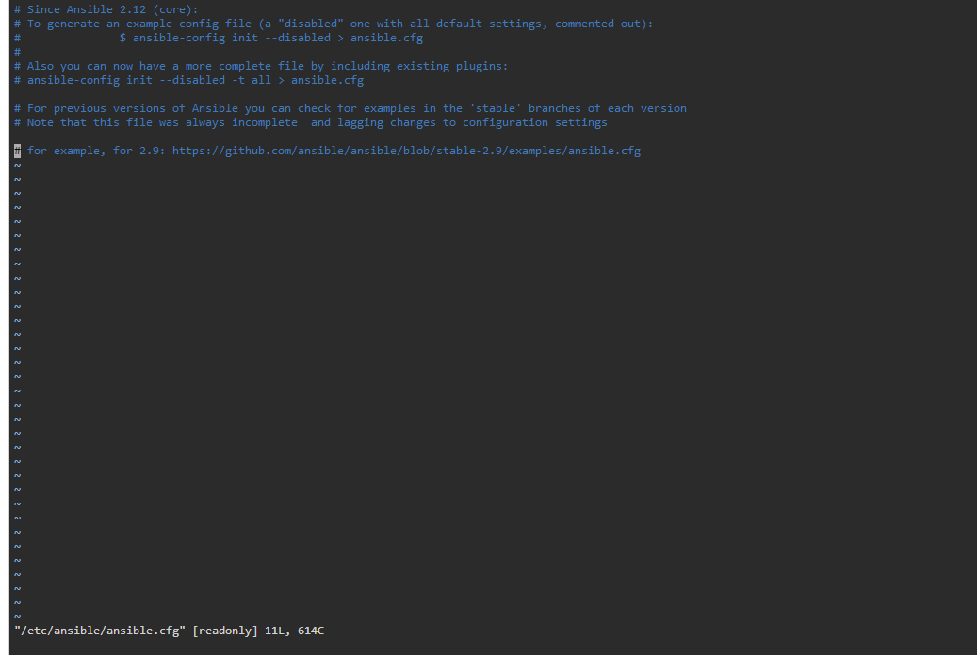

Making sure there is no aws dynamic inventory configuration

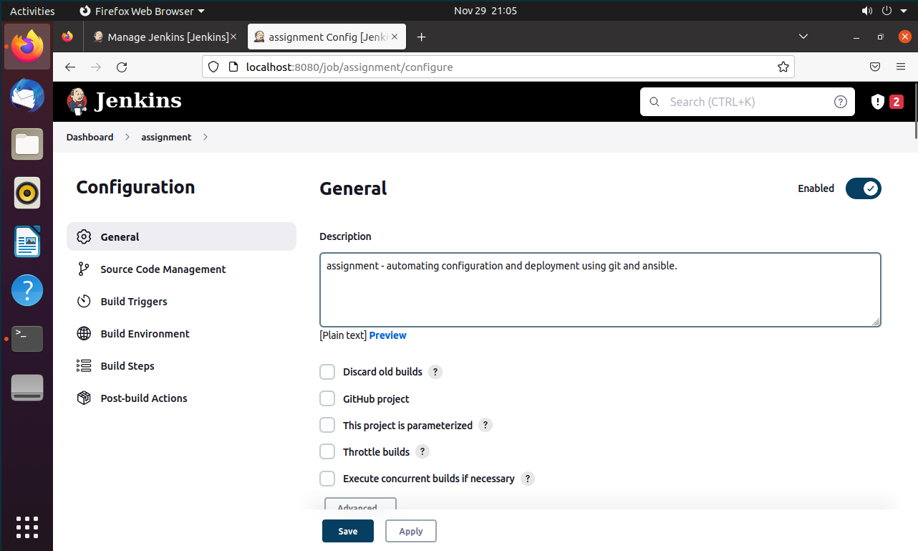

Building new job.

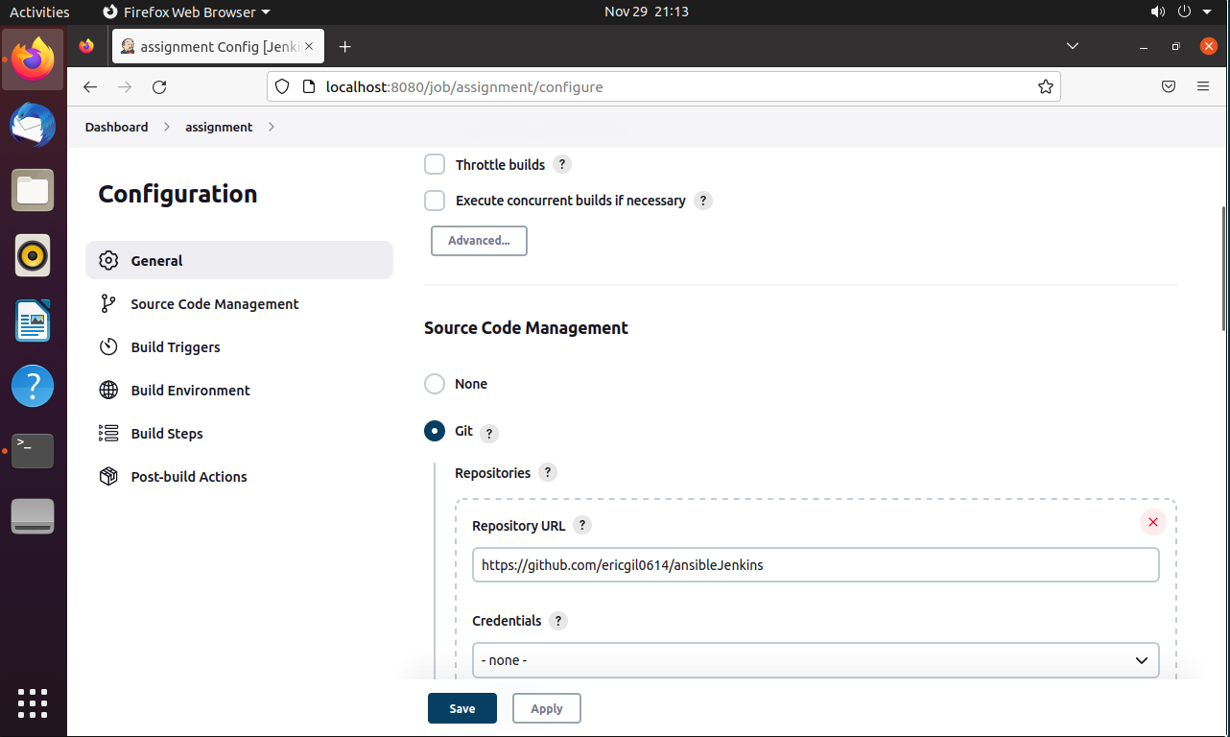

Setting up Github repo

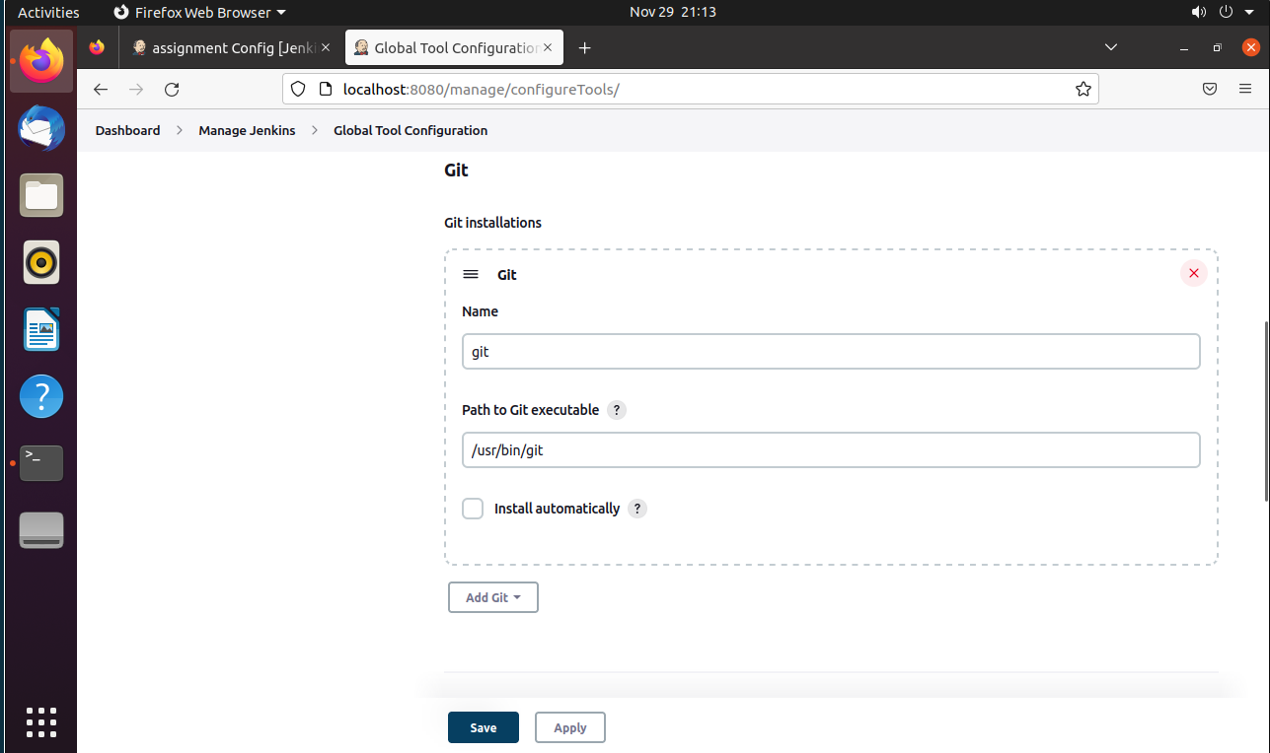

Making sure github global config has been set.

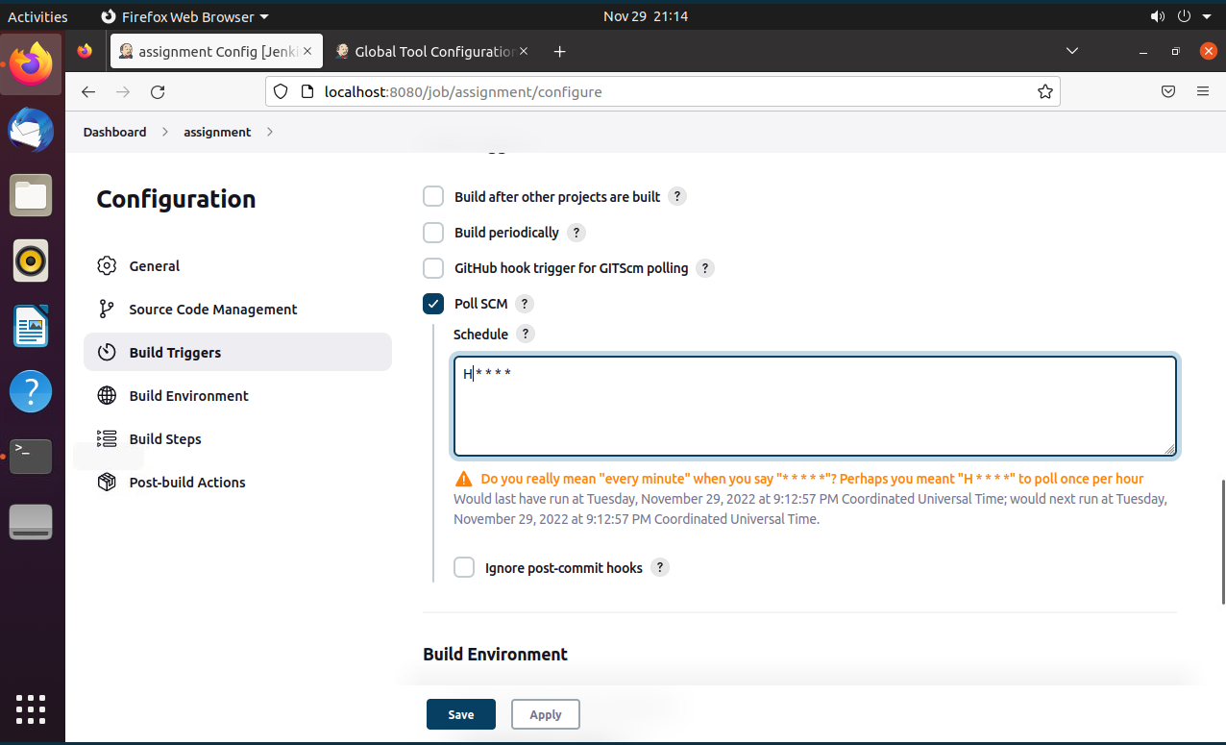

Scheduling it to be once per hour.

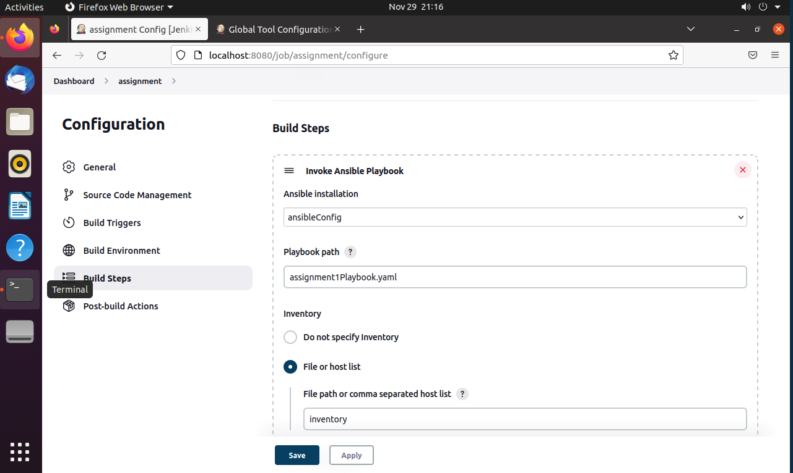

Adding build step - ansible playbook and inventory file.

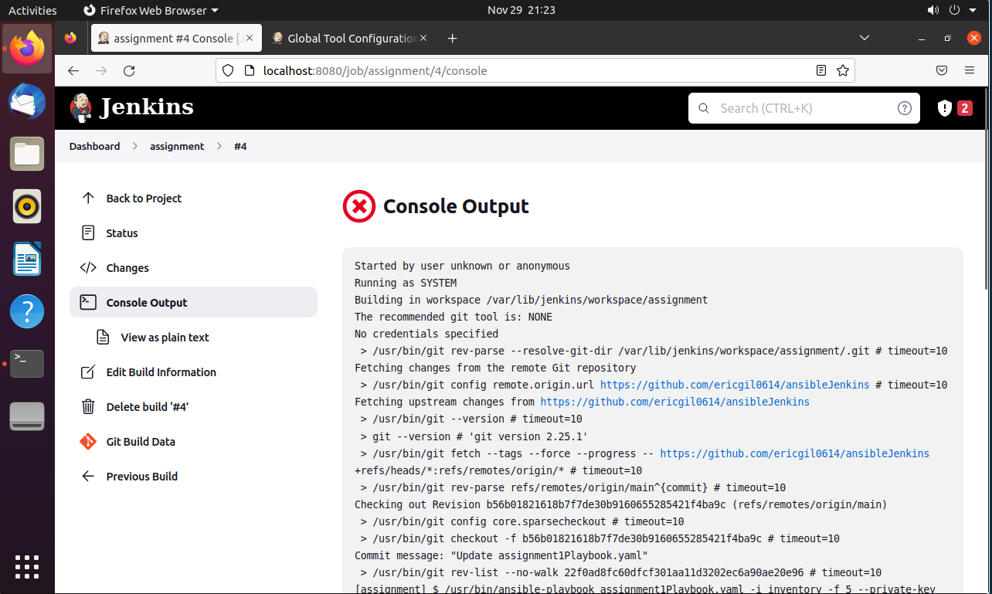

Few attempts to build the projects have failed.

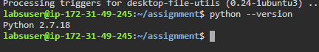

Fixed the issue by going to git config and adding proper git directory to it.

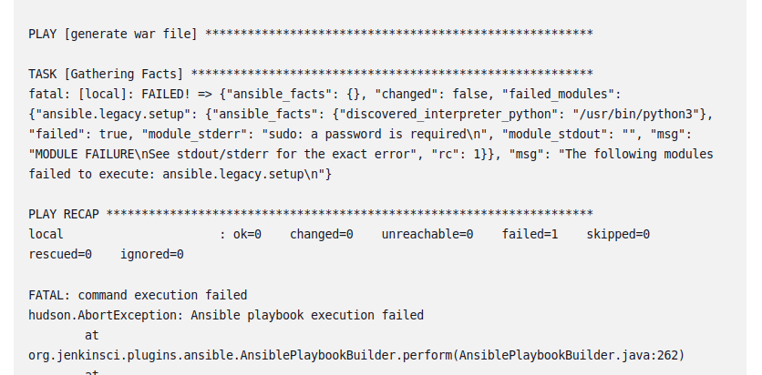

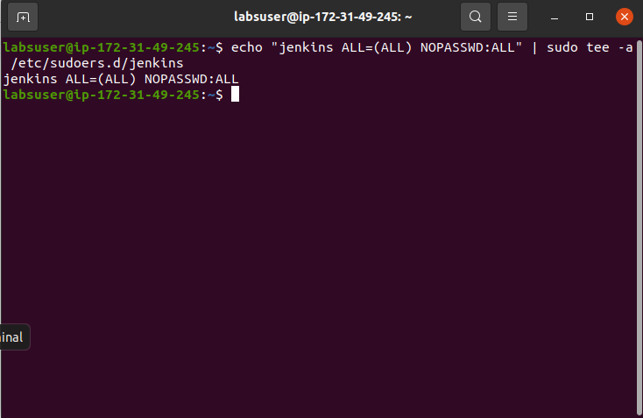

Had a sudo permission issue, but fixed with the terminal command above.

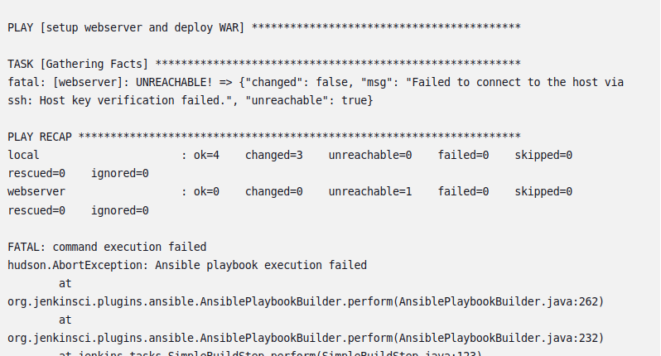

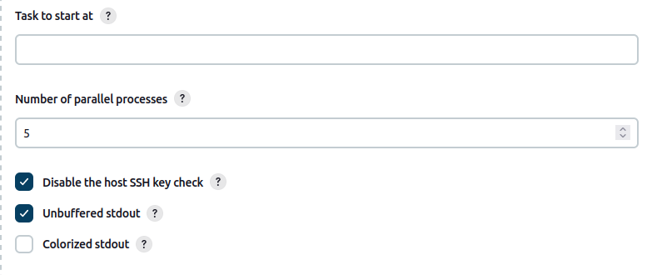

Another error encountered during another build. Fixed with disabling host checking in build settings.

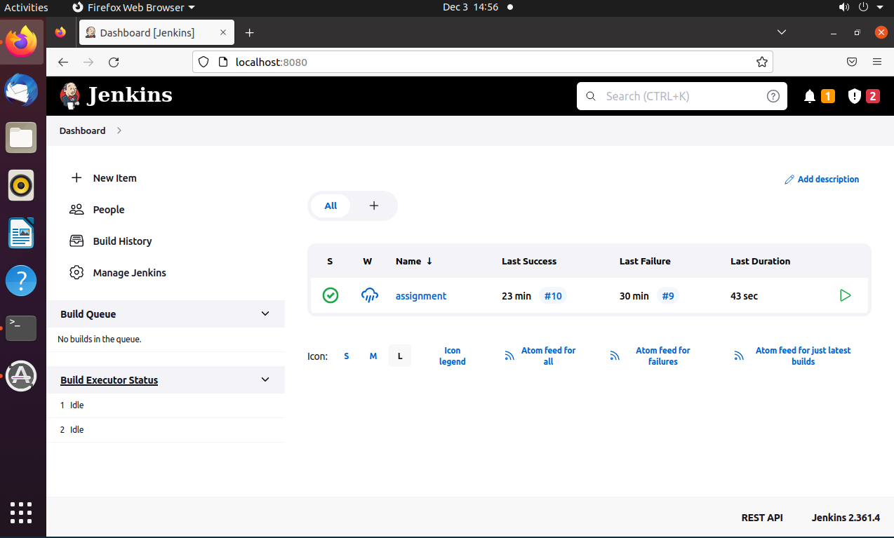

10th build finally built successfully.

